Tabbed Browsing Dev Spec
Author: Tony Schreiner
Last Modified: 10/8/2004 5:58 AM

1. Overview 1
1.1. Abstract 1
1.2. Definitions 1
1.3. Links 1
1.4. Goals 2
1.4.1 Tabs as a platform component 2
1.4.2 3rd Party Application Compatibility 2
1.4.3 Perceived Performance 2
1.5. Design Considerations 2
1.5.1 Single vs. Multi- Threading 2
1.5.2 Modal Dialogs 3
1.5.3 Reentrancy 3
1.5.4 Downlevel Support (XP Only) 3
2. Existing Architecture 4
3. Proposed Architecture 5
3.1.2 Code Split 7
3.1.3 Communication 8
3.1.4 Tabbed Window Manager 8
3.1.5 CInternetToolbar refactoring 8
3.1.6 Docking and undocking 8
4. Preliminary Performance Investigation 9

Overview

Abstract
Tabbed browsing introduces a lightweight way to manage multiple Web pages as a group. It also lessens the penalties involved with opening new pages by reducing taskbar clutter and allows new pages to load in the background without losing focus on the current page.
TODO: Architecture overview.

Definitions
IE7 – The next Internet Explorer

Links
Tabbed Browsing Spec
DUI Module Manager Dev Spec
\\tonyschr-lhdev\public\tabs\latest - IE Tabbed browsing prototype
\\tonyschr-lhdev\public\test\harness\taboc - Test harness for single vs. multithreaded investigation

Design Goals

Tabs as a Platform Component
Many IE7 features will use tabs to augment their functionality, so the ease and robustness of adding and manipulating tabs is a primary concern in the overall design. We are also planning to expose tabs to 3rd party extensions that wish to become tab aware.

3rd Party Application Compatibility
Tabs should not interfere with the vast majority of toolbars, browser helper objects, and other add-ins. Similarly, they should not interfere with applications that create/host IE7 components (mshtml, the WebOC, or CLSID_InternetExplorer).
The design needs to accommodate for the fact that legacy hosts and add-ins are not tab-aware. A future version of this spec will define the additional interfaces required for developers to make code tab aware.

Perceived Performance Improvement over Multiple Windows
In the worse case, tabbed browsing should be perceived by end users to be more efficient than using multiple windows. Because we are replicating most of the same UI elements, the design focus is on minimizing unnecessary overhead and ensuring that common operations such as opening a new tab, switching tabs, and closing tabs are highly responsive. We will also explore what we can do around prioritizing the active tab, in both local machine and network resources.

Design Considerations

Single vs. Multiple Threads

Performance
Multiple UI threads add additional overhead to the application, but may enable us to improve perceived performance by prioritizing the thread for the active tab over threads for background tabs and avoiding sluggish or stuttering behavior if activity on background threads is stalling the message pump.
See initial test performance data in Appendix P1. This compares IE (multiple windows), FireFox, Avant Browser, and the ExoTabs prototype.
TODO: Ongoing testing using the TabOC harness will help determine whether multiple threads help perceived browsing performance.
Note that the system automatically gives a performance boost to the UI thread of the foreground window. This would boost just the thread for the main frame, so we need to take this into account to prevent a decrease in performance for the active browser window.

Hang Resistance
Another motivation for using multiple threads is to prevent a single hung tab from hanging the entire browser window. This is particularly important in IE, as some well-known 3rd party add-ins currently hang the UI while content is being downloaded.
This is an area that could give IE a competitive advantage, as all popular 3rd party tabbed browsers host their tabs on a single UI thread and the entire application hangs when a single tab is blocked.

Hang resistance does not come free with multiple threads. The tricky part is avoiding blocking calls into a tab that might be hung. This will increase the complexity of the design and code and make stabilization more difficult. Note, however, that we do not need to have 100% hang resistance to benefit the end user.
The following table lists the most common scenarios we will need to make asynchronous to resist hangs.
Type | Example | Async Solution
Direct method calls | - Navigation, search, frame toolbar commands, keyboard accelerators | - Async COM  - PostMessage  - Worker Threads  - Heartbeat
Synchronous window messages | - SendMessage  - Forwarding messages to child windows  - Messages forwarded by OS? | - SendMessageTimeout  - Investigate why WM_SYSCOMMAND SC_SIZE gets blocked in test app
Synchronous window operations | - SetWindowPos  - ShowWindow? | - SWP_ASYNCWINDOWPOS flag  - PostMessage

The following is a brainstorm for methods we could use to resist hangs.
Note: If the frame itself is hung there’s nothing we can do. Users may be able to interact with the current tab if it isn’t involved in the hang, but that’s all. We are not aiming to solve that problem (other than making the frame robust).

Async COM
Async COM involves the creation of a custom proxy/stub layer which splits a single method into Begin_* and Finish_* methods. This is typically used by DCOM, where method calls are going out on the wire through RPC.
My understanding is that Async COM is directed toward preventing clients from blocking in scenarios where the server is alive and responsive, but needs to do a time consuming operation. For example a typical server would implement a thread pool to handle the incoming Begin_ method call, return right away, start processing, and the client can call back later using the Finish_ method (and/or use ISynchronize::Wait). Therefore, this would not prevent the client from hanging if the server does not respond to the Begin_ request because the server is hung.
Issue: Needs more investigation. MSDN documentation is light and I haven’t dealt with this before.

PostMessage
Rather than making direct method calls, all interesting frame to tab calls could be done indirectly using PostMessage. We could do this in a case-by-case fashion for the most common frame to tab commands such as back, forward, navigating to an URL, searching, etc. A simple IDispatch-style wrapper could make this relatively easy and transparent to use.
Issue: No way to get a return value. We can still sink events, though.
Issue: Didn’t Texas do something like this? Need to dig up the source…

Worker Threads
Rather than using Async COM directly, we could leverage some of the concepts such as creating a thread pool, and always using a thread from the pool to call from the frame into a tab. We could track which tab each worker thread is currently assigned to, preventing more than one thread from ever being piled up against a hung tab. Once a tab is hung, all method calls into it would synchronously fail, but the main frame and the rest of the tabs would remain usable.
Issue: Sounds iffy. Now every method call has to go from frame thread to thread pool thread to tab thread.

Heartbeat
A simplistic way to avoid hangs is to rely on a “heartbeat” message that each tab sends to the frame at regular intervals, and only call out to tabs that have an active heartbeat.
This reduces the chances that a call will be made to a hung thread – which is the primary scenario – but does nothing to address the problem of the call itself hanging. Depending on the heartbeat interval, there is still a relatively big time window where the frame would not know the tab is hung.

Painting Hung Tabs
Issue: When a tab is hung, do we try to take over painting for it? Will the OS try to force its will on us with the standard white background?

Reentrancy

Modal Dialogs
It’s unclear how we will handle modal dialogs that are launched from other tabs. The preferred option is to be able to block the display of the modal dialog while providing some visual indicator to the user that the tab has a pending dialog.

If we go with multiple threads, one option is to block that thread, but continue pumping a small number of messages (what’s needed?). Then, when the user clicks the tab to activate it, we can unblock the thread and allow the modal dialog to be shown.

Another option is to bring the tab that launched the modal dialog into focus just before the dialog is shown. This does not require blocking the thread and should be lighter weight, but is a less desirable user experience.
Issue: What are our options for hooking modal dialogs? (EnableModeless?

Downlevel Support (XP Only)
Which DLLs would we ship downlevel?
1) Big question: What can we bring downlevel?
a. What are our biggest code dependencies? DUI toolbars? What are the shared binaries which will make this difficult?
b. DUI: If we do a DUI tab bar, how do we take this downlevel? Is it re-implementing in Win32, or just losing some DUI functionality not available in XP? (Hopefully we can keep the majority of the implementation…)
c. Are we bringing the nav bar downlevel? Do we want to? (I think the answer is yes we want to keep the nav bar, what would stop us from keeping the nav bar, and how much work would we have to do to re-hook up all the tab stuff with the legacy toolbars if we couldn’t)
d. Shell integration: When I am tabbed in IE and swap over to the shell what happens? (Hopefully the shell place goes into the tab.)
2) Big question: What do we lose downlevel?
a. How much shell goodness do we lose?
3) How much time is added to our dev schedule for a downlevel release?
a. DUI port
b. Nav bar port
c. Shell integration
d. What else?

Existing Architecture
- Hosting model overview (CShellBrowser2 hierarchy)
- Where do major components hang off:
- Menus
- Toolbar
- Status bar
- WebOC
- Anything else?

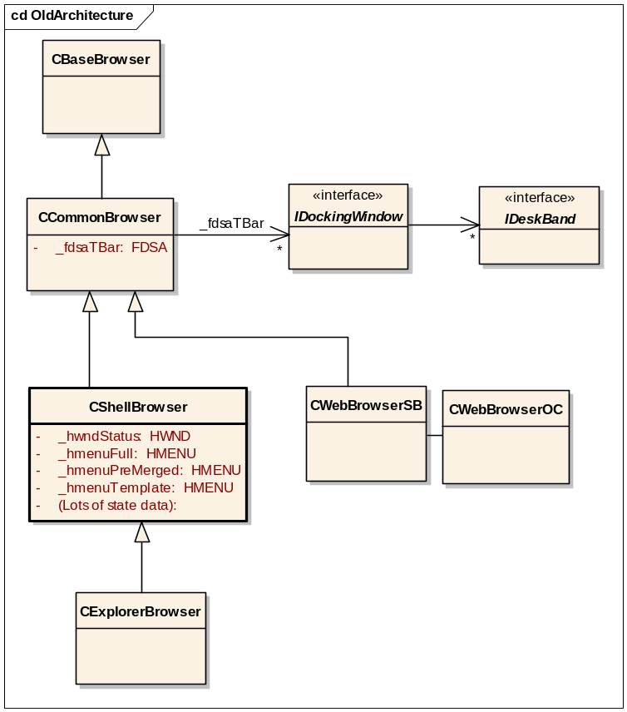
Today, CShellBrowser is the frame for an IE window, with the rest of the UI components hanging off of either it or a base class.
Toolbar and Explorer Bars
_fdsaTBar off of CCommonBrowser holds a collection of IDockingWindow pointers for the main toolbar (CInternetToolbar) and Explorer Bars. The toolbar holds a collection of IDeskBand pointers for each of the bands on the toolbar.
Menus
The menu handles and related objects are members of CShellBrowser, with some of the merging logic in CDocObjectHost. The menu band is a custom internal toolbar band in shell32, with the menus (except for Favorites) shown using TrackPopupMenu.
Status Bar
There are no abstractions around the status bar. It’s an HWND that’s a member of CShellBrowser.
Miscellaneous
CShellBrowser also maintains the state associated with the IE window, such as whether the status bar or toolbars are visible.

Proposed Architecture
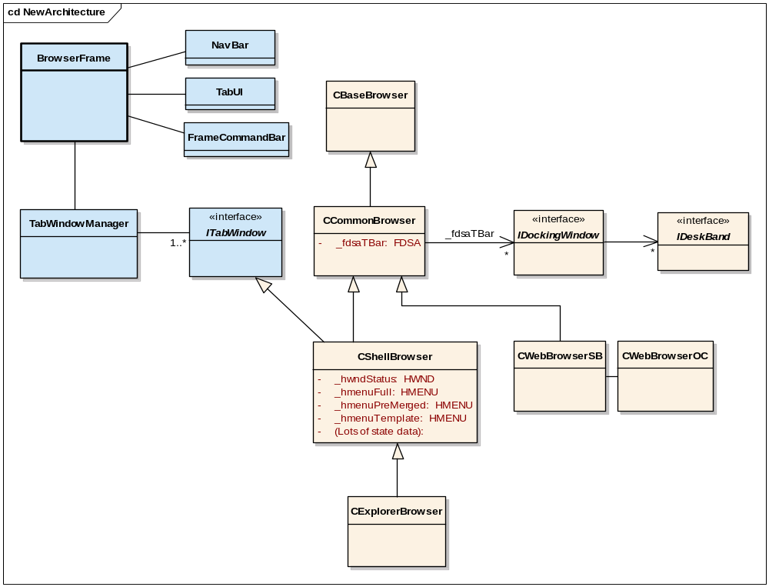
The proposed architecture is to keep CShellBrowser and associated classes mostly intact and make a new class, BrowserFrame, the primary frame for an IE window. BrowserFrame holds the new NavBar component, which has navigation controls, the address bar, and search box; a TabUI component to draw the tabs; and a FrameCommandBar component to host a set of toolbar buttons that are independent of the legacy toolbars.
The TabWindowManager holds the logical collections of tabs via. a new ITabWindow interface which is implemented by CShellBrowser. This class is responsible for brokering communication between frame and tabs, including any cross-thread marshalling.
The window hierarchy will not necessarily correspond to the object model. Depending on the UI design, some elements that are tightly integrated with CShellBrowser – such as menus – may be visually shown outside of CShellBrowser’s HWND.
Issue: What does CCommonBrowser do with toolbars and other components? Is any of this needed by the WebOC? It looks like there is a dual behavior, where some operations are no-ops when you host the web browser control directly, but are effective if you create a full IE and QI for IWebBrowser2.
Issue: What happens when somebody CoCreates CLSID_InternetExplorer and QI’s for IWebBrowser2? Do they just get the interface for the first tab and have to QueryService UP? These guys aren’t going to be tab aware.
Issue: How does placing the legacy toolbar outside of the CShellBrowser affect the overall interfaces and object model?

Overview and Design Decisions
The IE window consists of tightly coupled components for the frame, toolbar, menu, status bar, and hosted content (typically the WebOC or a shellview) that communicate primarily over public and private interfaces using COM.
The two ends of the spectrum for implementing tabbed browsing are:
- Host the WebOC in a completely new frame that is fully tab-aware. This is the approach taken by 3rd party IE-based browsers such as Avant Browser and Maxthon.
- Wrap entire top-level IE windows with a minimal frame that supports tabbing by showing and hiding the IE windows. This is the approach taken by the ExoTabs prototype.
The IE7 approach is closer to #2. By keeping the relationships between components intact we preserve the maximum amount of application compatibility. This approach is also lower cost, as the communication between the components does not need to be rearchitected.
A few major sub-components will be pushed into the outer frame and made tab aware. The first is the NavBar, which consists of the address bar, navigation buttons, and a search field. The UI to display tabs is also part of the outer frame, and the next generation of “Links” bar may be part of the outer frame. We would like to make the IE Command part of the outer frame as well, but more investigation needs to be done here.
Issue: Is command bar part of the outer frame or replicated? The largest issue is probably the buttons that change state as you navigate around, such as the Edit button.
Over time we would like to move toward #1 by refactoring the communication between components and moving them to the outer frame until just the WebOC is left. Again, the primary obstacle here is application compatibility.
Issue: If we don’t make clean break with non-tab-aware 3rd party add-ins now, will we ever be able to?
Figure H.1 illustrates how the windows would be broken up.
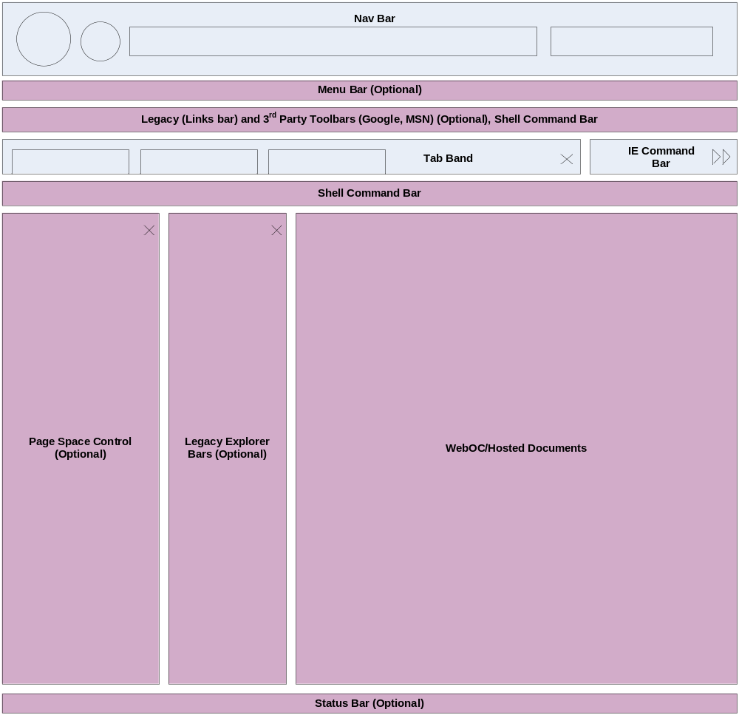
Figure H.1
The red blocks represent components that would be replicated for each tab. The blue elements represent new UI pieces such as the navigation bar and tab row. Note that the above diagram is a sample but representative layout. The exact placement of elements such as legacy 3rd party toolbars has not yet been determined.

Code Split
Talk about where to make the split. Need to investigate who creates/owns each of the components and how they would be affected.
Introduce TabWindowManager and related classes/interfaces.

Communication
Overview of the communication model.
Talk about async calls from frame into the tab, and how tabs fire events back into the frame. Need to consider things such as:
- Back/forward state, address bar text, search text (?)
- Progress (will be frequent, and multiplexed across tabs)
- Travel Log off back button
- MRU, autocomplete – single instance?
- Interacting with the DUI layout (need workitems for events?)

Tabbed Window Manager
CTabbedWindowManager
- Exposes a list of windows
- Enumerate tabs
- Reorder tabs
-

CInternetToolbar refactoring

Docking and undocking
Combined with the planned hosting mechanism, multiple threads enables stateful docking and undocking of IE windows from tabs – assuming they are the same IE process.

Preliminary Performance Investigation
I’ve finished compiling my data and experiences with the different approaches to tabs. The general gist of it is that the multi threaded approach eats up large amounts of memory. Exact numbers are below. I profiled each app with 5 tabs/windows open and with 10 tabs/windows open. The data shows that IE’s multithreaded approach uses approximately 5 times the memory of a single threaded approach. This has the effect of negating the performance gains of multi-threaded-ness. Large scale page-faulting creates a performance that is perceived by the user as being much worse than a single threaded approach that is just processor heavy.

Now for the memory usage data:

 | File Backed Pages | Dynamic Pages | Total Pages
AB-10sites | 3224 | 10396 | 13620
AB-5sites | 2755 | 6470 | 9225
ET-10sites | 3274 | 53808 | 57082
ET-5sites | 3001 | 42692 | 45693
FF-10sites | 3573 | 6609 | 10182
FF-5sites | 3403 | 6058 | 9461
IE-10sites | 3353 | 54260 | 57613
IE-5sites | 2978 | 40722 | 43700
AB=AvantBrowser
ET=ExoTabs
FF=FireFox
IE=InternetExplorer

If anyone needs an explanation of what the data above measures, I will be more than happy to provide one.

I also compiled my experiences using each of the browsers to see how the end user would perceive performance on each browser platform.

 | VBScript Loop
FF: | N/A
AB: | UI hangs when in loop. Rendering is slower when page is loading.
ET: | UI hangs when in loop. Renders very slowly.
IE: | Renders very slowly. Rendering and Navigation in other windows can hang or slow tremendously when in the loop.

 | Large Table
FF: | slight decrease in performance when navigating in another tab. when table tab does not have focus, table loads very slowly.
AB: | UI and rendering slower when table is rendering.
ET: | Rendering in other tab slower when table is rendering.
IE: | Some decrease in performance in other windows when table is rendering.

 | DHTML Lemmings
FF: | no noticable perf hit
AB: | DHTML apps hangs when several are running concurrently. Slow performance on all. Browsing in other tab slightly slower.
ET: | Memory consumption skyrockets with multiple instances open, UI hangs/responds very slowly.
IE: | Memory consumption skyrockets with multiple instances open, UI hangs/responds very slowly. Rendering in other windows slows considerably.

 | flash movie
FF: | no noticable perf hit
AB: | no noticable perf hit
ET: | no noticable perf hit
IE: | no noticable perf hit

 | flash game
FF: | no noticable perf hit
AB: | no noticable perf hit
ET: | game performs slowly
IE: | game performs slowly

 | plug-in (disney motion)
FF: | N/A
AB: | no noticable perf hit
ET: | no noticable perf hit
IE: | no noticable perf hit

 | plug-in (acrobat reader)
FF: | UI hangs when loading plug-in for first time
AB: | UI hangs when loading plug-in for first time
ET: | UI slow to respond when plug-in loads the first time
IE: | Page transitions occur slowly on first load.

The general feel of the data above is that multi-threaded-ness creates more perf problems than it solves. As a user I can understand it if my browser hangs for a second or two while acrobat is opening. What I can’t understand is why my browser starts to chug in a flash game due to lack of memory when I only have 4-5 tabs open, especially if there are other browsers out there that can handle the same flash game running at full speed with 10 or more tabs open.

If anybody has any questions or additional asks about this testing, just let me know. I’ve attached the list of sites that I went to for the testing. For 5 and 10 tab tests, I just went to the top 5-10 sites on the list. I also browsed to some of the others while I had one of the programs/stress tests open from the second column.

Thanks,
Andy

